Polaris Snowmobile jacket for sale. Price – best offer.

Jim Vickstrom, one of our member, has switched to Skidoo (no bashing of Polaris please, LOL) so he has no use for this jacked. Jacket is XL and is in excellent shape. No rips and all zippers work.
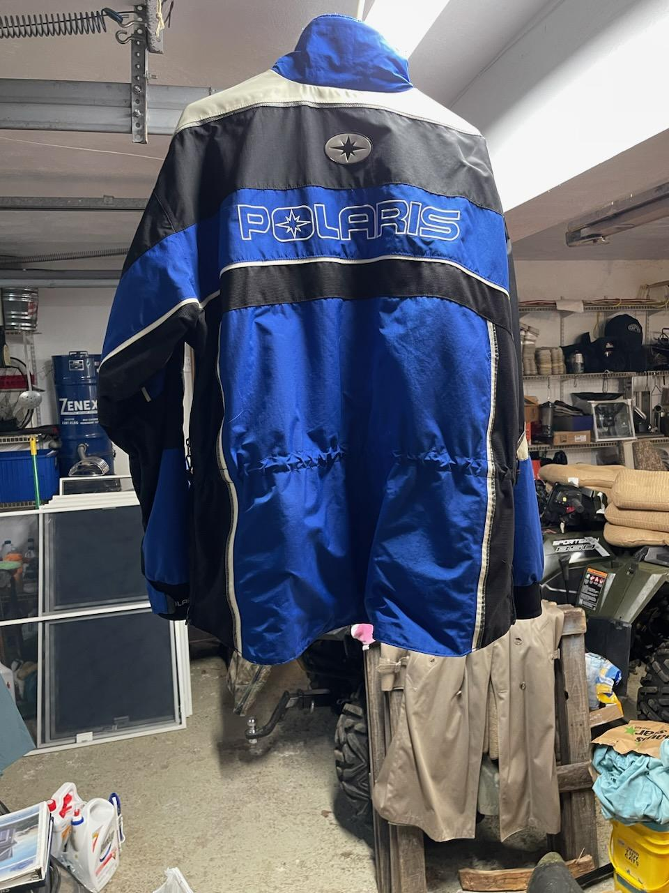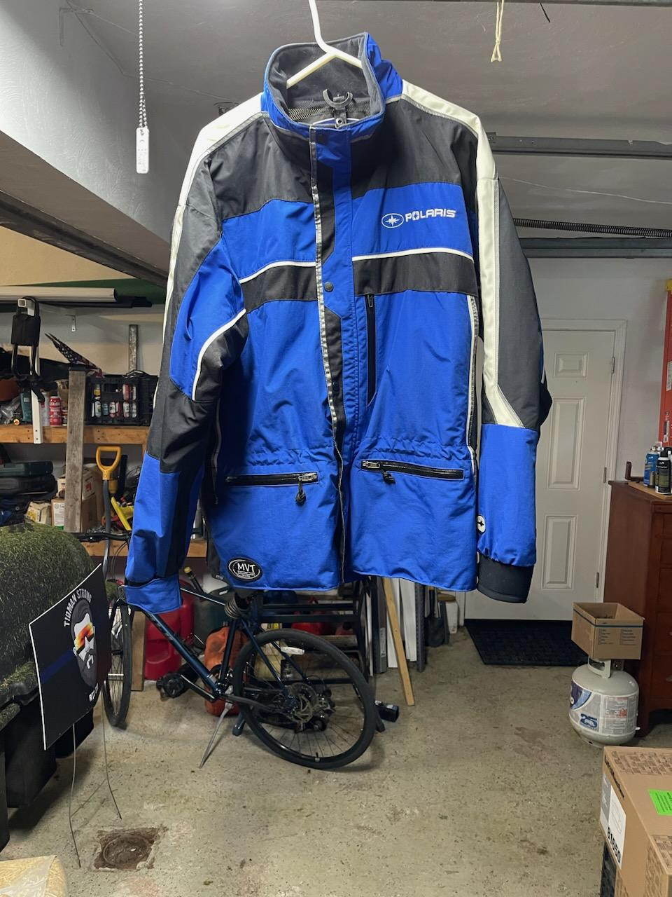

Contact Jim if you are interested. His phone number and email address are on the listing we send out a month or two ago. If you need, let me know and I can get it for you. Just don’s to list out on the web.
Larry

